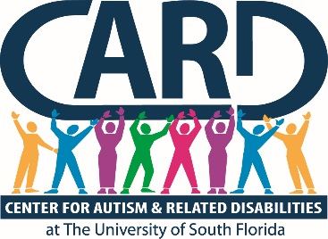

University of South Florida
Center for Autism and Related Disabilities
Final Report and Year End Summary

2018-2019

ANNUAL CONSTITUENCY BOARD REPORT

Submitted By

Karen A. Berkman, Ph.D.
Executive Director

University of South Florida (USF)
Center for Autism and Related Disabilities (CARD)
Final Report and Year End Summary
2018-2019

USF CARD Current Registry

 | Registry Data as of  June 30, 2019 | Comparative Data from June 30,2018
Registry Total | 7561 | 6966
Constituents on Registry by County
Charlotte | 105 | 102
Collier | 176 | 171
Desoto | 24 | 22
Glades | 0 | 0
Hardee | 42 | 35
Hendry | 28 | 27
Highlands | 191 | 164
Hillsborough | 3393 | 3093
Lee | 390 | 369
Manatee | 214 | 205
Pasco | 899 | 818
Pinellas | 1149 | 1069
Polk | 682 | 637
Sarasota | 268 | 254
Constituents on Registry by Age
0-2 | 31 | 27
3-4 | 216 | 203
5-15 | 3529 | 3400
16-21 | 1815 | 1620
22+ | 1970 | 1716
Annual New Referrals/Intakes | 614 | 606
Annual Registry Losses | 12 | 19
Annual Web Hits | 4,823,899 (318,973 visitors) | 4,631,786  (290,708 visitors)

*Registry total includes 7490 constituents with autism spectrum disorders (ASDs) and 71 with related disabilities (RDs). ASDs include autistic disorder, Asperger’s disorder, pervasive developmental disorders—not otherwise specified, Rett’s disorder and childhood disintegrative disorder, and RDs include dual sensory impairments or sensory impairments with other disabling conditions.

In accordance with section 1004.55, Florida Statutes (F.S.), and Rule 6A-7.0335, Florida Administrative Code (F.A.C.), USF CARD provided non-residential resource and training services for persons of all ages and levels of intellectual functioning with a documented diagnosis of autism, a pervasive developmental disorder not otherwise specified, an autistic-like disability, a dual sensory impairment or a sensory impairment with other disabling conditions. Services were coordinated with local and state agencies and school districts in an effort to not duplicate services. USF CARD worked closely with its partner agencies across the state of Florida to ensure high quality and equitable local, regional and statewide service provision in accordance with Rule 6A-7.0335, F.A.C., and consistent with the longstanding mission and values of the Florida CARD, a Florida Department of Education (FDOE) program since 1993. USF CARD primarily provided services within its 14-county catchment area, but also collaborated with other CARD centers and state agencies/projects on regional (e.g., regional trainings, Partnership for Effective Programs for Students with Autism [PEPSA] program) and statewide initiatives (e.g., annual CARD conference, development of online training content, support of statewide performance plan indicators, support for the reading initiative). Service delivery was consistent with the other six statewide CARD centers and was coordinated in the collective development of our projects’ annual service plans and via phone conferences with CARD directors and FDOE’s CARD liaison.

Outlined in this report is a summary of activities engaged in by the USF CARD during the period of July 1, 2018, through June 30, 2019. An abbreviated quantitative summary of center constituent registry and service activities is also presented, which reflects our activities across all relevant variables specified in our grant award agreement with FDOE. Detailed programmatic activity and constituent contact data can be found in the project tracking system (PTS) database.

In accordance with Rule 6A-7.0335, F.A.C., USF CARD implemented a plan that included the following:

- A staffing plan with, at minimum, individuals with expertise in autism or autistic-like behaviors and individuals with expertise in sensory impairments.

USF CARD prides itself on having a highly qualified multidisciplinary staff with impressive longevity in terms of years of service to the project. Our project staff members are professionals with expertise in the following discipline areas: psychology, behavior analysis, special education, and social work. Our executive director has been with the project since 2003, and our director has been with the project since 2004. This continuity of leadership has contributed a high level of expertise and administrative stability to our project, which has certainly served to enhance our project performance and outcomes.
Our project leader also participates in service grant writing, fundraising, publications and presentations, and is recognized locally and nationally as an expert in the field.

- A direct service plan that must address individual and family assistance in the home, community and school. The project shall not supplant responsibilities of other state and local agencies.

USF CARD provided individual and direct family assistance (IDFA) across contexts (home, school, and community) in fiscal year (FY) 18-19. IDFA is defined by the CARD centers as any contact with any individual and/or family in reference to a specific CARD constituent. Families are advised of the range of services provided by USF CARD and how to access those services when needed. Detailed information on how to access USF CARD services is also available on our website (http://card-usf.fmhi.usf.edu/). All new families who require services complete an intake with a CARD consultant, where the constituent and family needs are assessed and a service plan developed. The CARD consultant with whom the family meets is assigned to the family for ongoing individual and direct family assistance and all related future clinical contacts. IDFA contact data are collected regularly, entered into CARD’s Filemaker reporting database, summarized quarterly and entered into the PTS for quarterly and annual reporting.

Summary of Annual IDFA Data

Total IDFA contacts delivered annually | 6,371
Total individuals served annually | 12,239

- A technical assistance (TA) and consultation services plan for providing specific intervention and assistance, utilizing all available community resources, to clients of the project, the clients’ family, school districts, and other service agencies and individuals as appropriate.

USF CARD provided Technical Assistance (TA) services throughout our community in FY 2018-19. TA is defined by the CARD centers as assistance requested by an agency or program that is not related to a specific CARD constituent. Agencies requesting such services are directed to a TA request form on our website (http://card-usf.fmhi.usf.edu/services/request/technical-request.html). Once a completed form is received by our central office, a CARD consultant with expertise relevant to the TA request is assigned to contact the agency, assess need and determine a plan of action. TA contact data are collected regularly, entered into CARD’s Filemaker reporting database, summarized quarterly and entered into the PTS for quarterly and annual reporting.

Within our technical assistance services, CARD-USF partnered with PEPSA to support individual teachers to implement effective educational practices through a teacher partnership program. Teachers, FCIC staff and state-wide CARD staff collaborate to develop classroom innovations.
CARD-USF continues to pair a CARD staff member with a selected educator to improve the classroom experience for students with ASD. CARD-USF had three teacher partners during this reporting period. Outcomes are shared statewide through PEPSA’s website and teacher day of the annual statewide CARD conference.

CARD-USF early childhood team and executive director have continued our multiyear partnership with HIPPY to bring their home instruction program to over 22 children with ASD in Hillsborough County during 2018-2019. CARD has provided direction and training to home visitors to build capacity to serve this population successfully. CARD has provided direction and training to home visitors to build capacity to serve this population successfully.

Summary of Annual TA Data

Total TA contacts delivered annually | 3,985
Total individuals served annually | 10,847

- A professional training program plan that includes developing, providing and evaluating pre-service and in-service training in state-of-the-art practices for personnel who work with the populations served by the project and their families.

USF CARD provided extensive local and regional trainings for professionals in FY 2018-19 in an attempt to ensure that all professionals working with CARD constituents are trained in state-of-the-art “best practices” and are highly qualified. All USF CARD trainings are open to all interested parties in the community, including family members, at no cost. Agencies requesting training are directed to a training request form on our website (http://card-usf.fmhi.usf.edu/services/request/training-request.html). Once a completed form is received by our central office, a CARD consultant with expertise relevant to the training request is assigned to contact the agency, assess need and determine a plan of action. We continue to expand the array of online training content each year. Training data, including participant demographic information, and participant evaluations are collected regularly and entered directly into the PTS for quarterly and annual reporting.

The statewide CARD centers were charged by FDOE to develop an online training module to address the topic of preventing seclusion and restraint of students diagnosed with ASD. CARD-USF is the lead for all CARD Centers on managing the data for the FDOE priority of preventing seclusion and restraint through the online module we created. The statewide CARD centers were charged by FDOE to develop an online training module to address the topic of preventing seclusion and restraint of students diagnosed with ASD. CARD-USF is the lead for all CARD Centers on managing the data for the FDOE priority of preventing seclusion and restraint through the online module we created.
During this reporting period, 21 teachers, principals, paraprofessionals, behavior specialists, ESE Specialists, social workers and guidance counselors across Florida completed the module successfully.

CARD-USF assisted with the 26th Annual CARD Statewide Conference in Orlando, Fl. in January, 2019. It offered a separate track for ADOS II training. The conference was attended by 890 families and professionals. This conference offered 2.5 days of internationally known and local experts on ASD and related disabilities. The presenters gave current and valuable information to teachers, families, professionals and individuals with ASD. It provided access to evidence-based information that promotes best practices in education, early intervention and quality community based life-styles for individuals with ASD and related disabilities.

In April 2019, we co-hosted the annual Promising Pathways Conference in Ft. Myers with 277 people in attendance. These conferences draw people from areas all over the State of Florida to gain new knowledge in a wide array of topics related to ASD.

In our ongoing partnership with districts, we offered our annual Autism Summer Institute for teachers which was attended by teachers and related school personnel. We had a great turnout of 411 for day one and 361 for day two. This event continues to draw new interest as we showcase nationally known presenters and local experts. Each year, CARD-USF has been involved in the planning of other educational events that seek to improve the supports and inclusion of students with ASD.

In addition to the variety of larger scale trainings, CARD-USF also offers a variety of professional online trainings, local and regional trainings on topics related to ASD. During this year, we added an algebra series for teachers of students with ASD to the array of online trainings on CARD-USF’s website.
CARD-USF is actively engaged annually in developing and disseminating new materials to build the capacity of educators. We produced 10 new materials, tools, and/or training modules this year. CARD-USF continues to work closely with the public and private school districts to provide trainings and follow-up materials and technical assistance. Another important way that CARD-USF distributes materials, training content and resources is through our website that is maintained and updated regularly to include evidence-based educational approaches for students with DD. Our website showcases online trainings for educators, resources and materials for administrators.

USF CARD has been working with law enforcement across our region to provide training and technical assistance to ensure positive interactions occur with individuals diagnosed with ASD. We provided several trainings throughout the year to CPI officers as well as police and sheriff’s departments. During this reporting period, CARD-USF provided 10 trainings for law enforcement or First Responders.

Summary of Annual Training Data

Total number of onsite local trainings/workshops | 182
Total number of participants | 3965
Total number of times online trainings viewed | 6714
Total number of visitors for online training page | 8381
Total number of annual regional trainings/workshops and/or summer institutes | 3
Total number of participants | 840

- A public education plan to increase awareness of the public about autism, autistic-like disabilities of communication and behavior, pervasive developmental disorders, dual sensory impairments, and sensory impairments with other disabling conditions.

CARD hosted or participated in numerous public education and awareness events throughout our catchment areas in FY 2018-19, including regional community resource and health fairs, autism awareness events with professional sporting franchises (e.g., Tampa Bay Lightning) and many others. Specific events and related data can be found in PTS. CARD-USF facilitated an educational event for students at a Hillsborough County High School. The guest speaker, DJ Savarese, is a non-speaking young man with autism. Through Augmentative Communication, he discussed the importance of inclusion. In addition, we hosted a movie showing of DJ’s story at USF with a meet and greet afterwards for families to connect.

Summary of Annual Public Education/Awareness Data

Total number of annual general public education presentations | 80
Total number of participants | 10,953

- Description of how the project will interface with the medical community to ensure the appropriate use of medical consultation in the provision of services.

USF CARD maintained collaborations with the local medical community, specifically consulting with hospital employees and adaptive care committee to problem solve issues related to patients affected by autism.
Reviewed training opportunities for hospital staff; consulted with hospitals on using best practices for children diagnosed with autism; disseminated an emergency information packet called Medipal for families to use on a child’s seatbelt or backpack with medical information in an emergency; expanded the medical provider information in the CARD Filemaker database. A resource and referral database of medical providers by discipline has also been maintained. Lastly, we have an ongoing partnership with Special Day Foundation and UF College of Dentistry where CARD provides annual trainings and ongoing technical assistance to new dental residents. We have also created a variety of social experience stories and visual materials for dental offices to ease patient stress and anxiety. CARD-USF created a guidebook titled: Autism and Mental Health Issues: A guidebook for mental health professionals. This guidebook was developed to provide mental health professionals with information on autism and mental health concerns, what professionals need to know and resources that are available to support mental health professionals working with individuals with a diagnosis of ASD. CARD-USF provided a two-day intensive workshop titled” Advanced Clinical Training: CBT to Treat Anxiety for Individuals Diagnosed with ASD”. During this experience, participants received in-depth information about autism spectrum disorder and using the evidence-based practice of CBT to provide strategies to treat anxiety issues that often interfere with an individual’s daily activities. Dr. Nadeau, a nationally known psychologist for his work in this area, was the presenter. He has brought a wealth of knowledge to the autism community through his work at Rogers Behavioral Hospital where there are multiple programs for youth and adults with ASD who experience significant anxiety. Also, CARD-USF collaborated with the Pediatric Surgery Center in Hillsborough County to provide technical assistance and training for post-surgery situations for patients with ASD. We created visual aids, choice boards and a pain communication board. CARD works with St. Joseph Hospital providing training for staff to best interact with patients with ASD.

- Description of its working relationship with and support of the constituency board, as defined in s. 1004.55, F.S.

USF CARD continued its close collaborative relationship with its constituency board. The board has maintained its membership of people who represent several USF CARD counties. The constituency board reviewed annual program budget and goals, and hosted quarterly meetings with CARD staff to review programmatic and budgetary priorities. The constituency board operated in accordance with approved by-laws, and proposed constituency board members’ names were submitted to the presidents of USF and the Autism Society of Florida, as specified in statute. Constituency board members participate actively in fundraising events to help support USF CARD operations. Finally, board members participate in relevant trainings related to their own and their family’s needs and interests throughout the year, including the annual CARD conference.

- Dissemination of Appropriate Nutritional Information.

CARD-USF disseminated appropriate nutritional information to constituents in various formats. Information about food chaining and expanding food choices was developed into multiple brochures. In addition, a complete booklet on practical strategies to support feeding aversions was posted on our website and printed for distribution at public awareness events. Trainings on nutrition are archived on the USF CARD website and are available for ongoing viewing by families. CARD-USF created 2 brochures called “Food Chaining Milk” and “Food Chaining French Fries” to give information and strategies to parents and professionals around this nutrition difficulty.

Summary of Supplemental Activities in Support of Program Objectives

The USF CARD executive director has been engaged in working collaboratively with other entities within and outside of USF in supporting the ever-expanding scope of our project and our growing community needs.

USF CARD continues to strengthen its program through the cultivation of strategic community partnerships. This past year, we continued building on the close relationships with our 14 school districts, continued our collaboration with the medical and diagnostician community through trainings and resource dissemination, and enhanced our community outreach efforts through numerous public awareness efforts, in collaboration with local schools/agencies.

Our team continues to offer regularly distributed substantive and informative newsletters. The CARD Connector is a brief monthly newsletter that clinicians from around our communities may contribute to as well as our constituency board chair along with announcements. The CARD Community Connection newsletter is a full edition that comes out two times a year. They are both on our website archives.

Our Autism Friendly Business Initiative has had a major impact for families who are now able to enjoy community recreational, leisure and educational activities, as well as take care of their family needs through shopping, banking, and medical health and wellness. We continue to collaborate with community partners to create a welcoming experience for individuals with ASD. CARD-USF teamed with the NHL team, the Tampa Bay Lightning, to be a part of an “Autism Awareness Night” for families. We staffed the event and provided technical assistance during the game. We also were interviewed for a PSA segment played at intermission. Designated CARD staff continue to serve on the Mayor’s Advisory Committee to continue expanding and monitoring the “Autism Friendly City of Tampa” initiative.

CARD-USF facilitated three ESE District Workgroup meetings. The agendas included CARD-USF information, updates from the districts, and an opportunity to discuss varying topics regarding building continued success for their schools.

Safety concerns within the autism population have been addressed by USF CARD in multiple formats. This year, we added a new brochure called “Autism Spectrum Disorder and Hurricane Safety” in English and Spanish. We continue to be involved with agencies such as Safe Kids (Statewide Safe Kids, Pasco, Pinellas, Polk, Manatee, Sarasota, and Tampa Safe Kids). We have been involved with the Josh the Otter Water Safety Initiative and curriculum. During this reporting period, we supported many events with Josh the Otter. This included a “lunch and learn “for teachers at the Autism Summer Institute. CARD-USF continues to provide safety kits to families in need of support in this area.

USF CARD’s executive director contributed scholarly work to the field by publishing articles in the area of nutrition, post-secondary education and employment and evaluating video modeling for transition age job seekers.

Fundraising FY 2019 (July 2018-June 2019)
CARD is responsible for fundraising 2% of its annual budget, per statutes. We met our annual goal for fundraising with events like Fiesta by the Bay for Autism and Cycling for Autism (we received part of the proceeds through the Tampa Interbay Rotary Club)A CARD employee was a member of the USF Faculty Staff Campaign committee and was responsible for helping to reach the University’s annual goal of pledges.

Special Events and Projects:
- Collaborated with ZooTampa, The Florida Aquarium and MOSI for the sensory friendly event “Day of Discovery” during autism awareness month
- Co-hosted Promising Pathways conference in Ft. Myers
- Hosted Fiesta by the Bay for Autism Fundraiser
- Safety kit campaign for autism awareness
- Updated resources for CARD library
- Trick or Treat with the Greeks at USF
- Board Game Night for young adults
- Night of Giving reception

2018-2019 CARD Annual Caregiver Satisfaction Survey

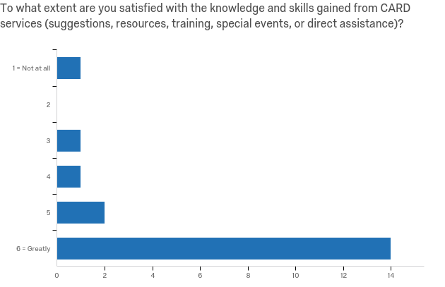
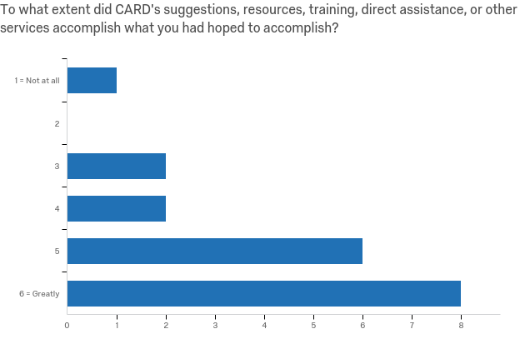
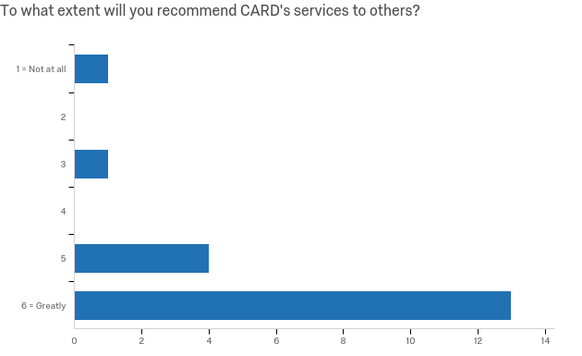
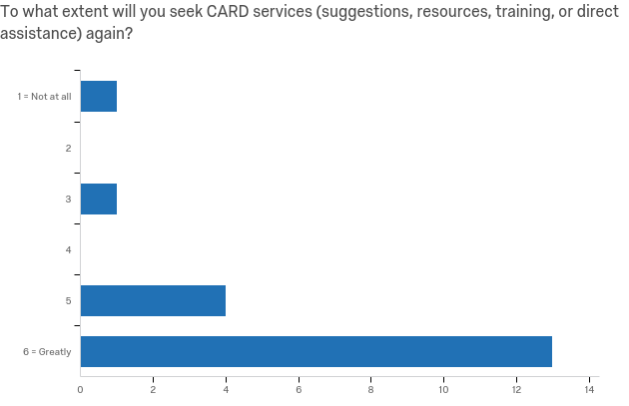

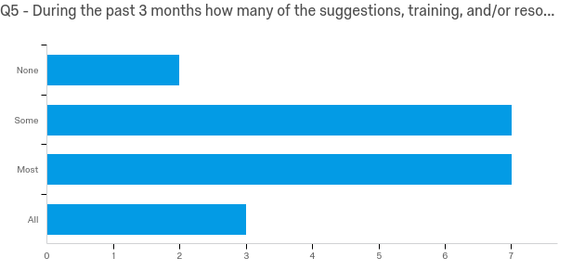
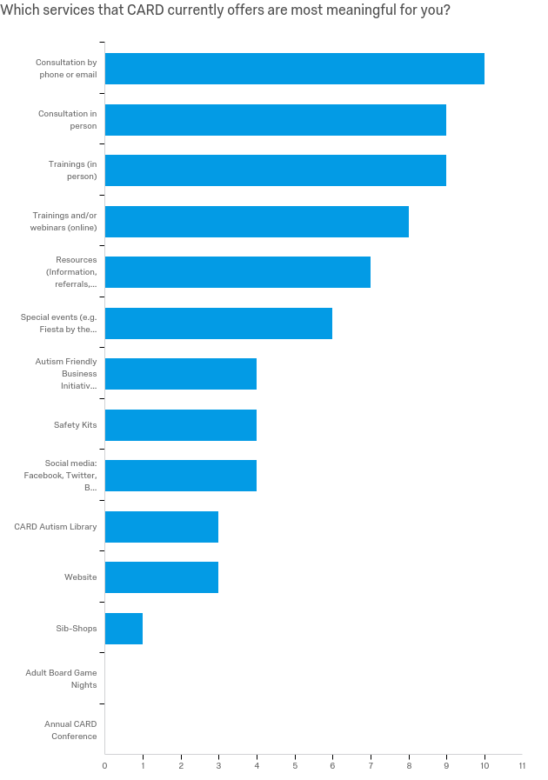
2018-2019 CARD Satisfaction Survey for Technical Assistance

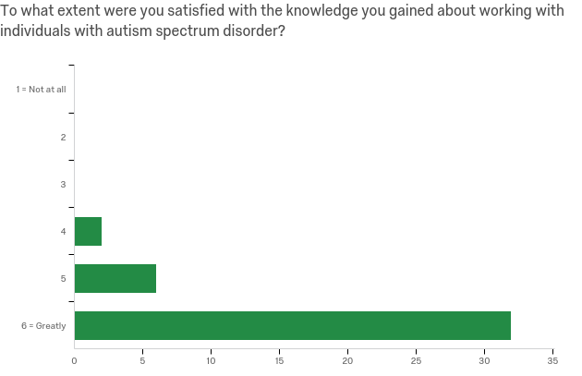
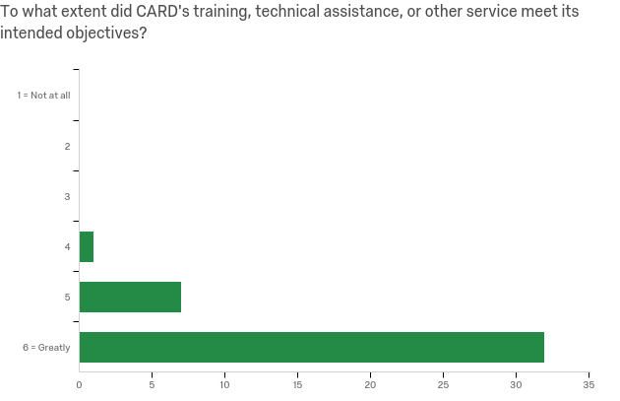
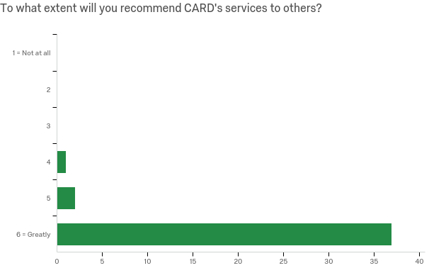
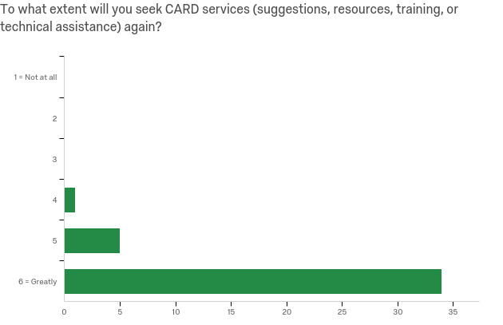

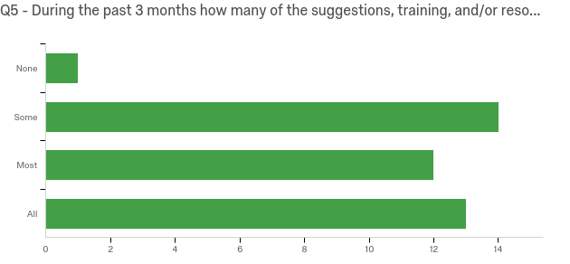

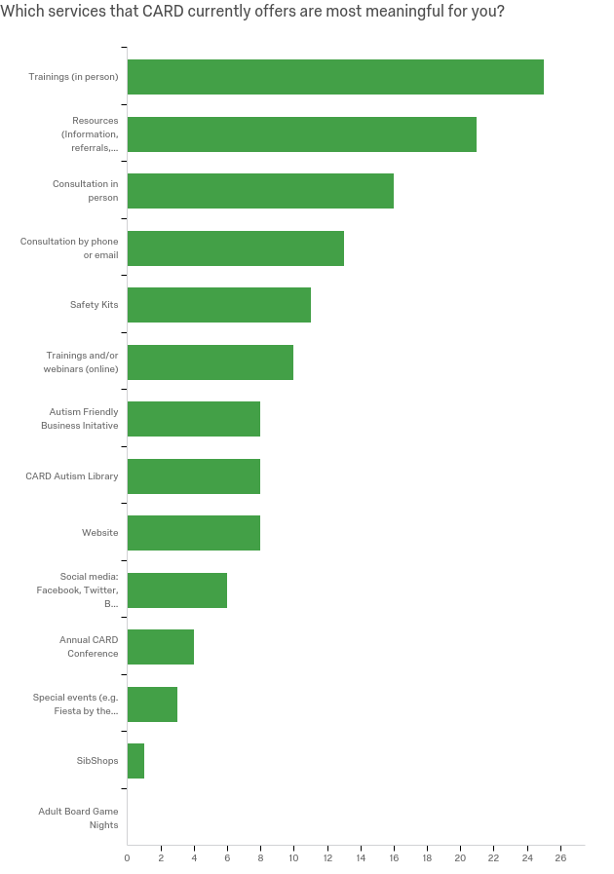
Constituency Board Objectives

1) Continue to meet on at least a quarterly basis.

2) Submit a final report of annual board activities to USF president,
Dr. Currall.

3) Review activities and outcomes of specific support efforts undertaken by CARD.

- Coordinate planning and implementation of annual fundraising events such as Fiesta By the Bay as well as participation in other regional events.

- Support workgroup activities in the areas of fundraising, community outreach and education.

I have reviewed this document and on behalf of the constituency board of CARD-USF, approve the final report for the year 2018-2019.

_______________________________________ __________________

Kristen Nieves, Board Chair Date
CARD-USF

